(1 form per room)
First Name:
Last Name:

Check-in date: |  | Check-out date:
Occupancy:
Room category: | ROH (Run of the House) (Basic Category Garden View)
Special Requests:
Flight Information:
In order to book your transfer included from/to the airport please contact our Guest Service Department Ph: +52 (998) 881 9836 ext. 32825 – 32825 or send an email to dxguestservice@hotelxcaret.com once your reservation has been confirmed.
Telephone number:
E-mail:
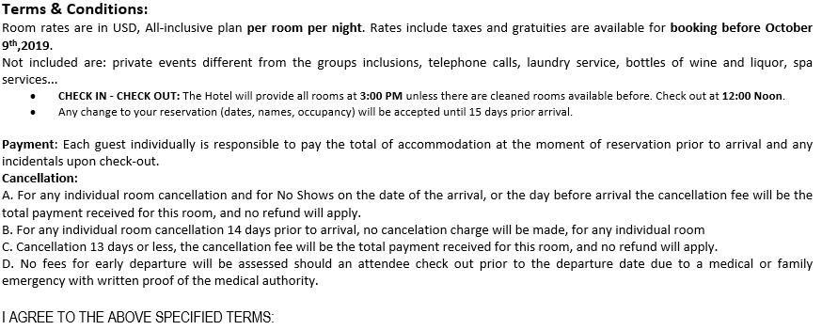
Date / Name / Signature

